## Unit 19 Homework: Protecting VSI from Future Attacks

### Scenario

In the previous class, you set up your SOC and monitored attacks from JobeCorp. Now, you will need to design mitigation strategies to protect VSI from future attacks.

You are tasked with using your findings from the Master of SOC activity to answer questions about mitigation strategies.

### System Requirements

You will be using the Splunk app located in the Ubuntu VM.

### Logs

Use the same log files you used during the Master of SOC activity:

* Windows Logs
* Windows Attack Logs
* Apache Webserver Logs
* Apache Webserver Attack Logs

### Part 1: Windows Server Attack

Note: This is a public-facing windows server that VSI employees access.

#### Question 1

* Several users were impacted during the attack on March 25th.
* Based on the attack signatures, what mitigations would you recommend to protect each user account? Provide global mitigations that the whole company can use and individual mitigations that are specific to each user.

I would white ip the companies devices ip’s so that way it will block outside sources that are doxing the servers. Also would give employee key card generators with random numbers that they would have to enter if they were trying to access from outside of company issued devices and are logging on personal devices they have code to enter that expires after a min and generates a new code. Also have it set to a certain time limit that they can access the server from a non company devices.

#### Question 2

* VSI has insider information that JobeCorp attempted to target users by sending "Bad Logins" to lock out every user.
* What sort of mitigation could you use to protect against this?

Inform the employees that there is a phishing email going out to try to steal log information. Have a meeting or virtual course that shows employees what phishing email looks and quiz them on it each month over it. Tell them check for spelling errors in email address and check to see what kind of vendor the email address if it's not one that is used by company dont answer and if you have questions to ask supervisor about it and they have questions they can contact security team and find out if they are actually locked out or not.

Part 2: Apache Webserver Attack:

#### Question 1

* Based on the geographic map, recommend a firewall rule that the networking team should implement.
* Provide a "plain english" description of the rule.
  + For example: "Block all incoming HTTP traffic where the source IP comes from the city of Los Angeles."
* Provide a screen shot of the geographic map that justifies why you created this rule.

Firewall rule should use is Block all incoming HTTP traffic where the source IP comes form the Ukraine.

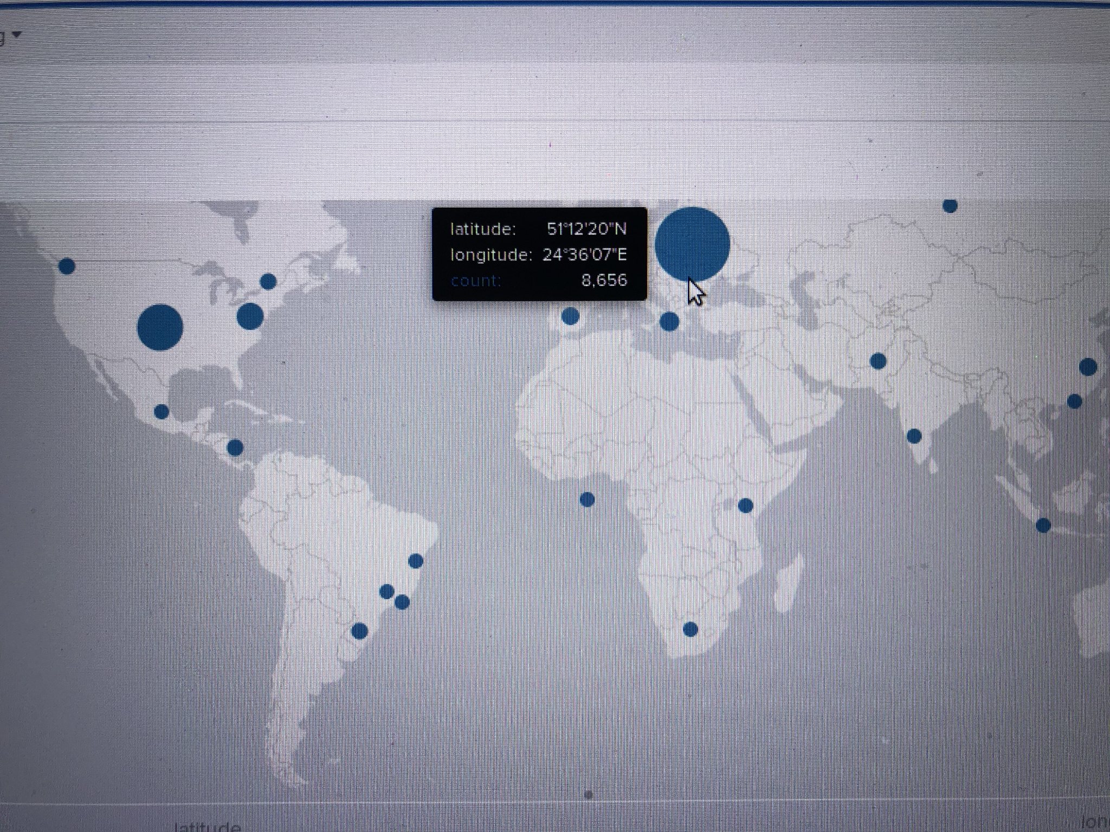

### 

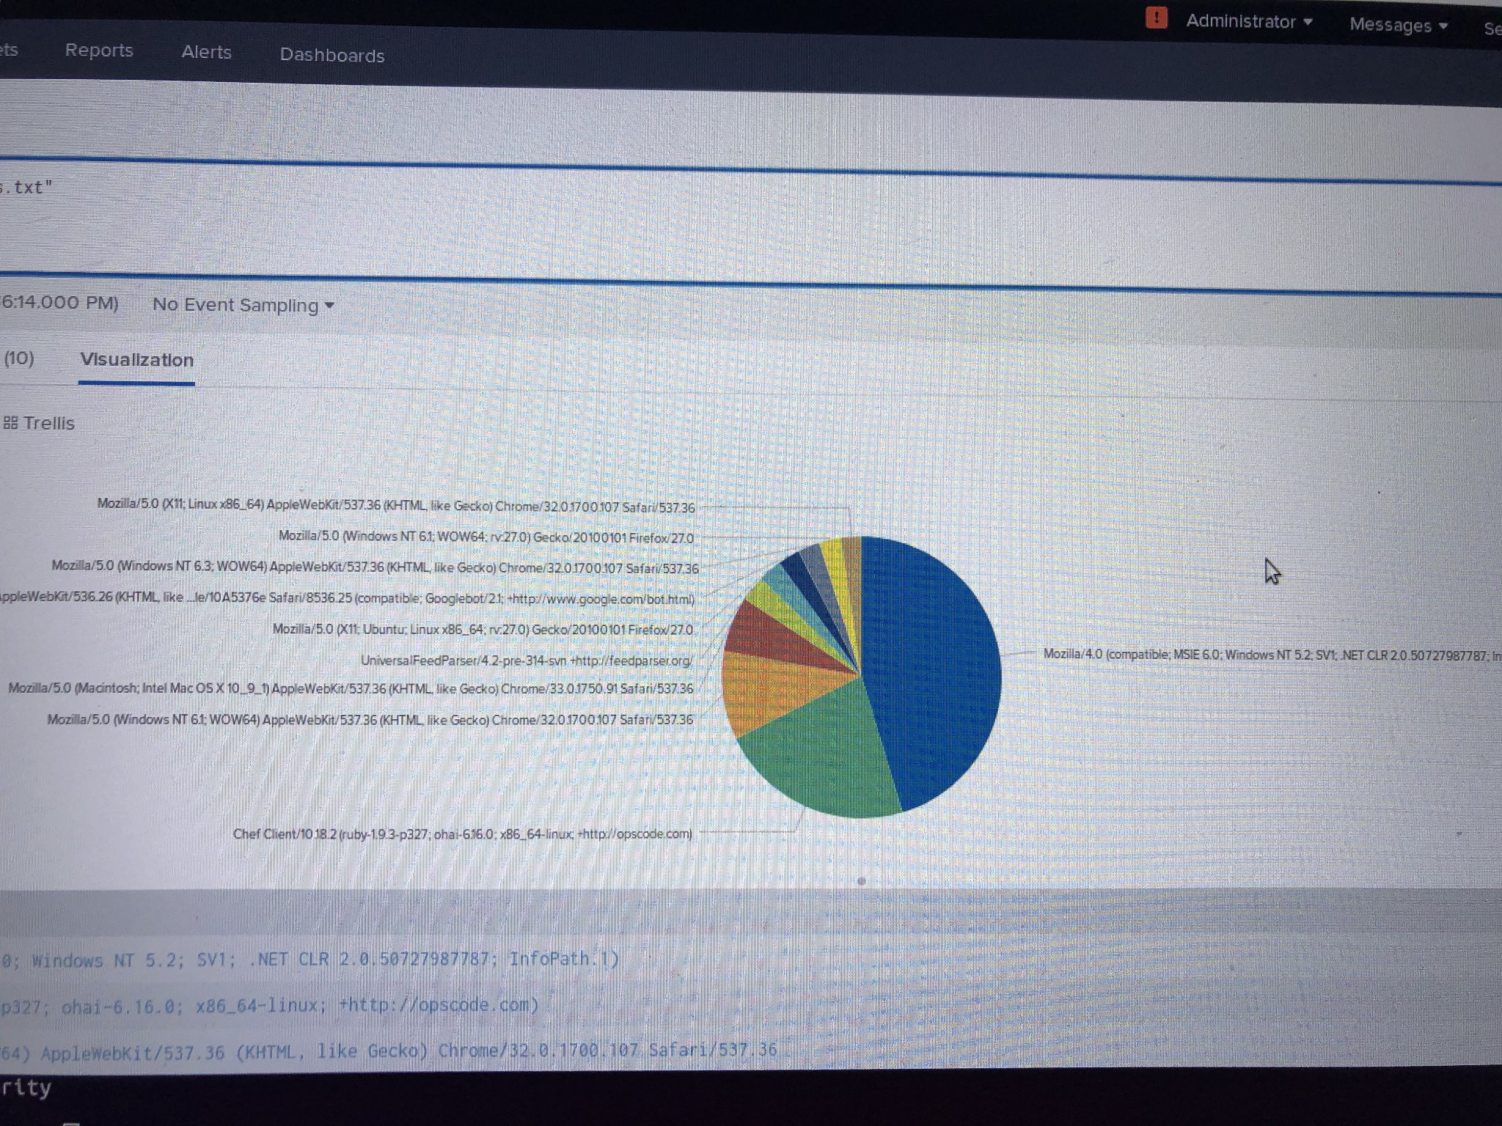

#### Question 2

* VSI has insider information that JobeCorp will launch the same webserver attack but use a different IP each time in order to avoid being stopped by the rule you just created.
* What other rules can you create to protect VSI from attacks against your webserver?
  + Conceive of two more rules in "plain english".
  + Hint: Look for other fields that indicate the attacker.

1. Block linux access to the server since that shows that's where the attacks were coming from.
2. Use authentication so if its program that someone is running attack form it will have hard time getting like using photos of asking for certain object in the photo that machine would have issues picking up on but normal person wouldn't to help mitigate the attacks.